USER GUIDE FOR USING THE WEBSITE

1. **Account**
2. ***Register an account***

* Click Sign Up Now! button at the bottom to register as user.

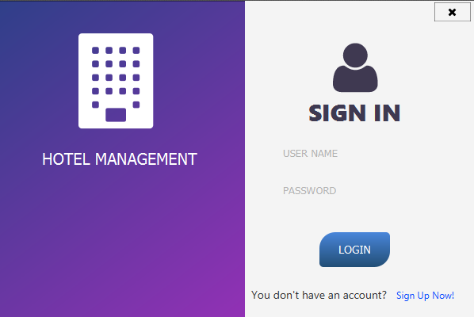

* Enter personal information to register form, then click Create Account button

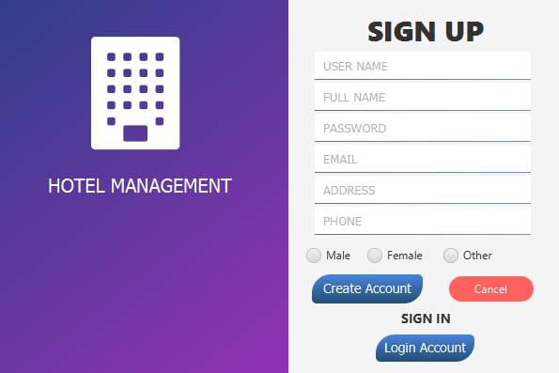

1. ***Login to your account***

* Click Login Account button at the bottom, then enter email and password match to registered account, then click Login.

**

1. ***View profile, booking history, and edit information, password***

* *View profile and edit information:*  Hover on username on NavBar, then click profile user button. *You can view or edit your personal info.*

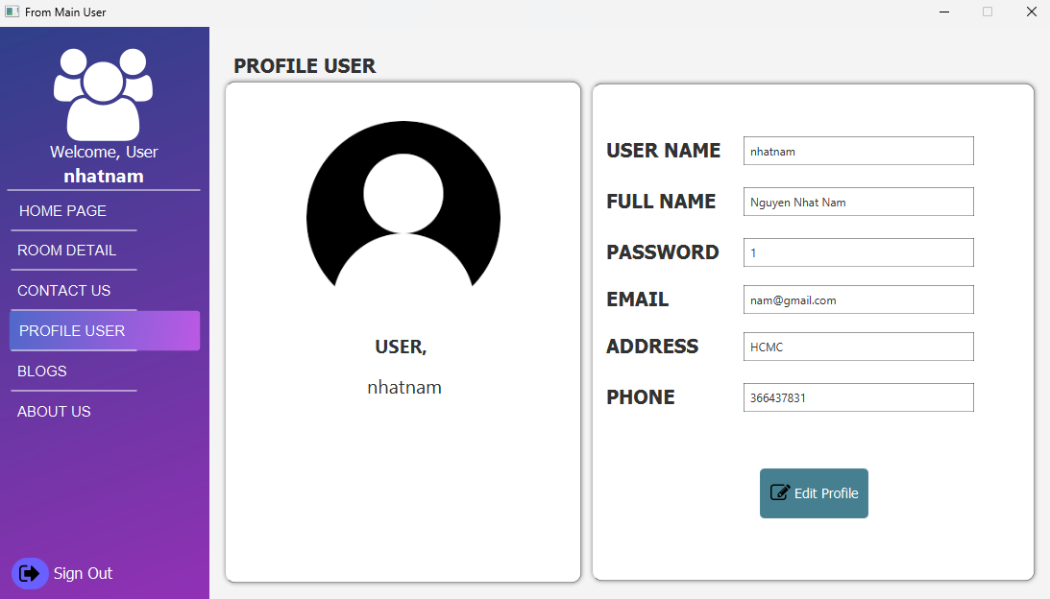

1. ***Room Details***

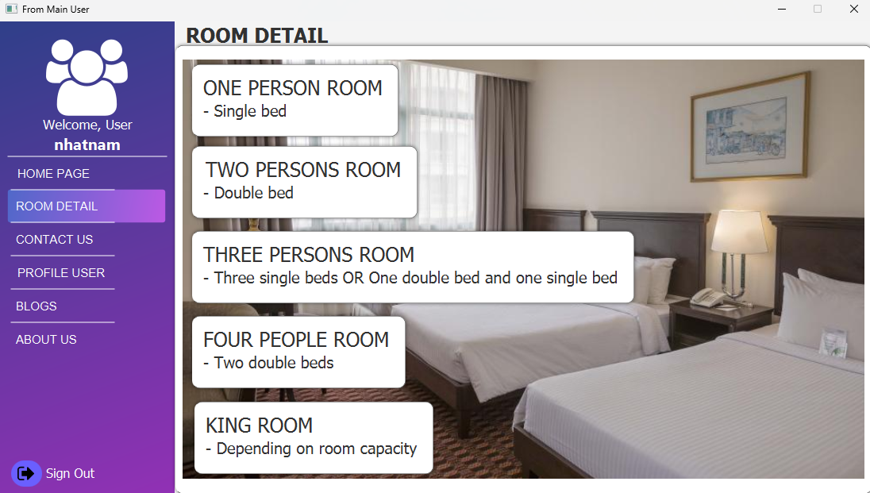

-Hover to Room Detail on Navbar ,click the Room Detail button to know more about each room types.

1. **Blogs and Other information**
2. ***Read blogs and leave comments***

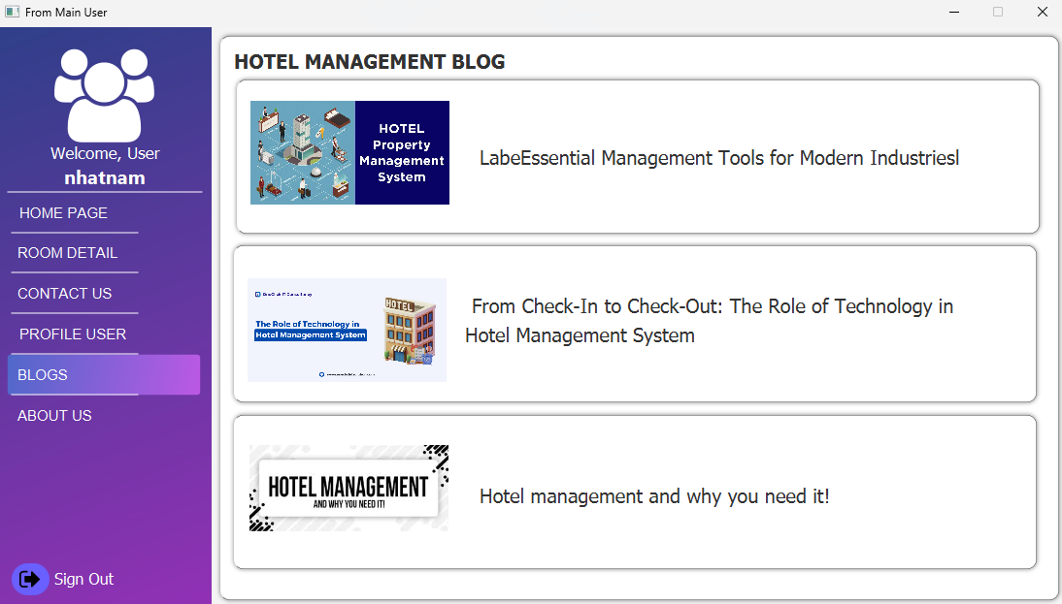

-User click on Blog button on NavBar to read our blogs.

**2. About Us**

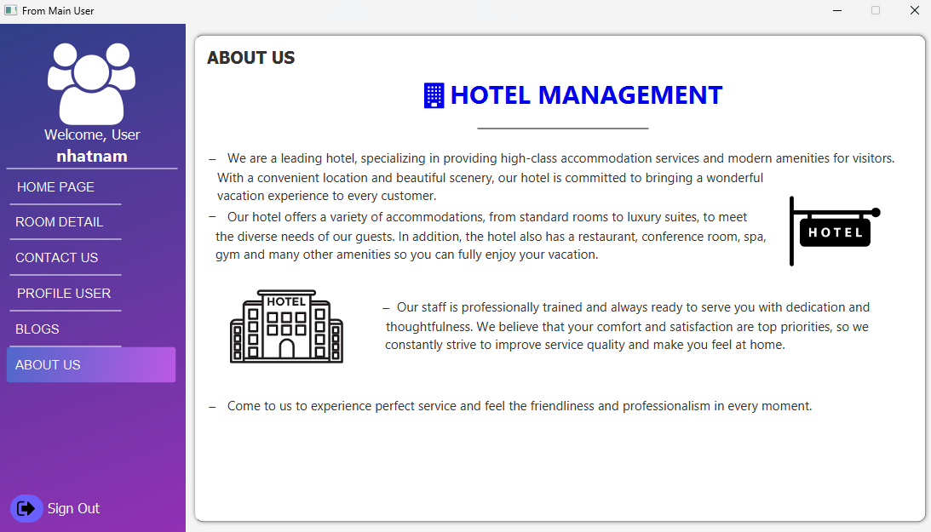

- Click on About Us button on NavBar , it will redirect you to About Us page, where you can read more information about us.

**ADMIN DASHBOARD**

**ADMIN DASHBOARD:**

**Main dashboard page**

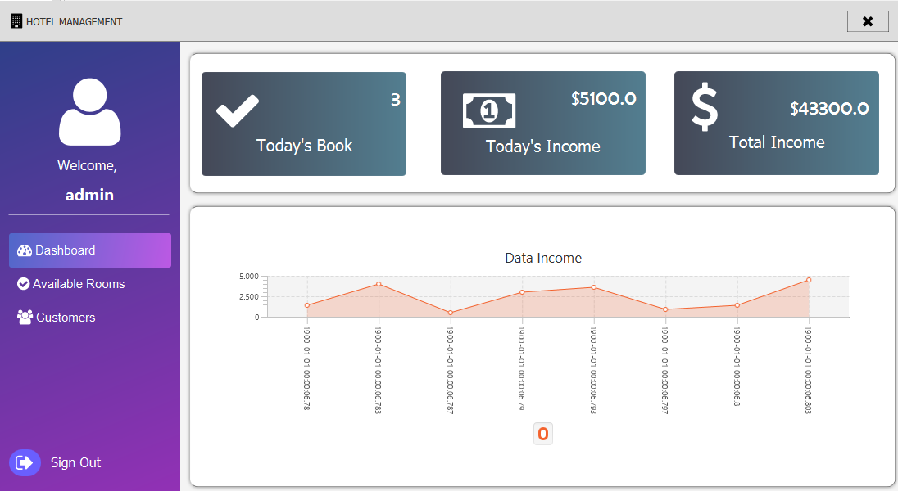

Display overall information of website in nearest 30days, click to More info in each card to view more detail.

The side bar include route to all managegement page of each class.

**Available Rooms**

Click on Categories button on sidebar to redirect Available Rooms page:

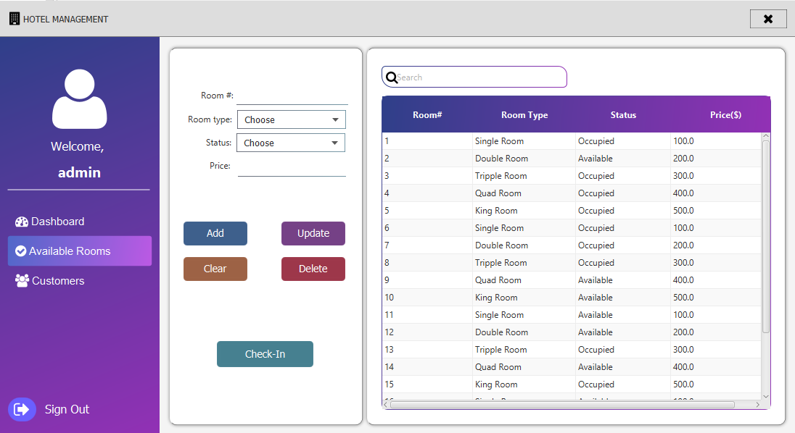

Admin can manage Rooms on this page: add new Rooms, edit or delete existing rooms and Check-In.

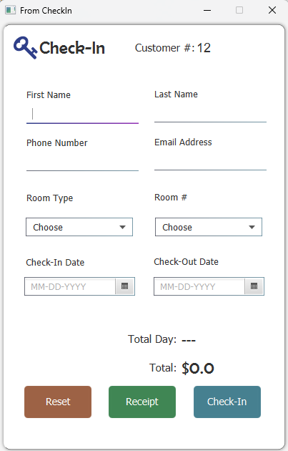

**Customers**

* Click on Customers button on sidebar to redirect Customers page:

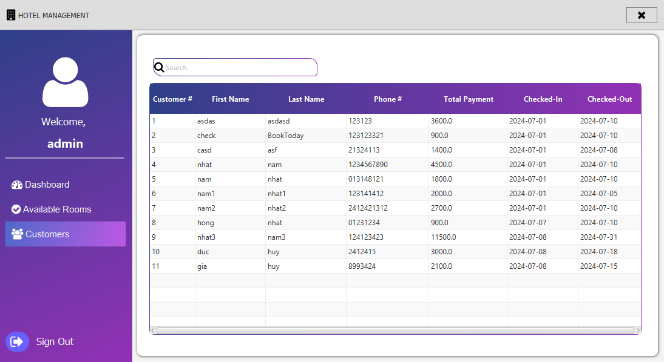

* Admin can search Customer information in this page